**Ch9:**

***Q.6***

Assume we have an internet (a private small internet) in which all hosts are Connected in a mesh topology.

* Do we need both network and data-link layers?

We need the data-link layer, but not the network layer. Each node has a direct link to every other node. This allows a node to address any other node with only the physical address. The data-link layer would also allow two nodes to communicate even if their direct link is broken via hopping through other nodes.

* Do we need routers in this internet? Explain.

We do not need routers. Since we have only one network and that network is connected in a mesh topology, each node is able to address every other node with only the physical address.

***Q.7***

In Figure below,

1. Do you think that system A should first check its cache for mapping from N2 to L2 before even broadcasting the ARP request?

Yes, System A should check its cache for mapping from N2 to L2 before even broadcasting the ARP request. It’s possible System A has previously communicated with System B and already knows System B’s physical address.

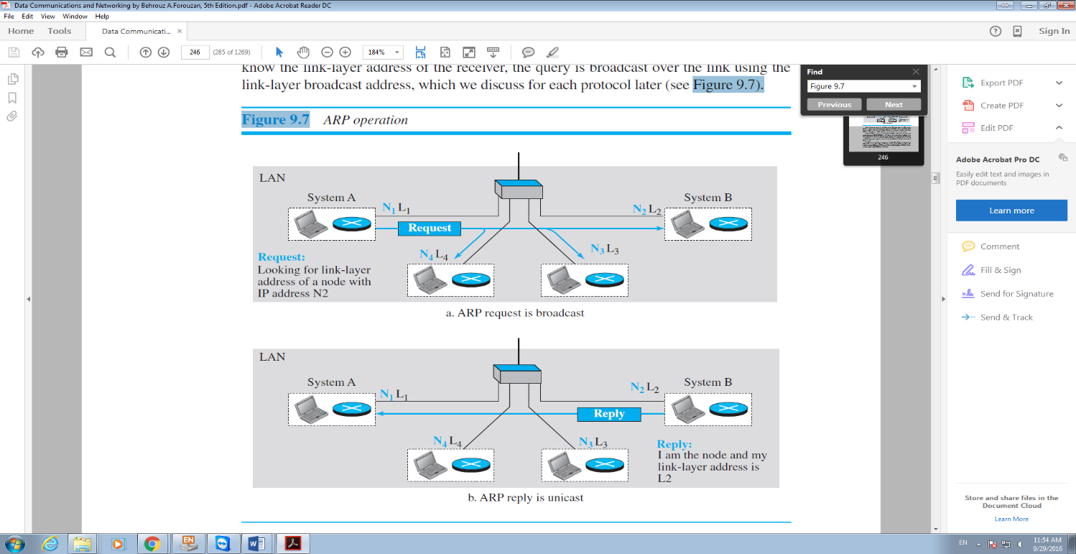

**Figure 2 ARP OPERATION**

1. Assume system B is not running the ARP program. What would happen?

System B would not respond to the ARP request received from System A. System A would not receive the physical address of System B and would not be able to communicate.

1. Assume the network in Figure 9.7 does not support broadcasting. What do you suggest for sending the ARP request in this network?

If the network does not support broadcasting, System A can send the ARP using a Multicast Address since the jurisdiction is local.

***Q.8***

Assume Alice is travelling from 2020 Main Street in Los Angeles to 1432 American

Boulevard in Chicago. If she is travelling by air from Los Angeles Airport to

Chicago Airport,

1. Find the end-to-end addresses in this scenario.

2020 Main Street, Los Angeles

1432 American Boulevard, Chicago

1. Find the link-layer addresses in this scenario.

2020 Main Street, Los Angeles

Los Angeles Airport

Chicago Airport

1432 American Boulevard, Chicago

***Q.9***

How many IP addresses and how many link-layer addresses should a router have when it is connected to five links?

A router should have 5 IP addresses and 5 link-layer addresses when connected to 5 links. Each IP Address and Link-Layer address pair define the router in one network.

***Q.10***

Can two hosts in two different networks have the same link-layer address? Explain.

Yes, because link-layer addresses are local to a network.

**Ch10:**

Using any programming language, you know, implement the following:

1. Hammer:I/p is a character, and O/p is a hamming code for that character.

2. De-hammer:I/p is a hamming code, and the O/p is text.

3. Burst Error Corrector: The input is a string that will be hammed.

Then De-hammed. The O/p should identical to the I/p.

Please refer to the hamming hand out.

I implemented the above requirements in a .NET Console application using the C# programming language. The application accepts the following 3 commands.

Command “h” followed by a single character prints the corresponding 11-bit codeword.

Command “d” followed by an 11-bit codeword prints the corresponding character and supports correcting single bit errors.

Command “b” followed by a string of up to 32 characters prints:

1. The codeword matrix of the input string
2. Each burst message sent
3. The received codeword matrix
4. The reconstructed string

The following two screenshots show example outputs of the program. The first screenshot shows an example of each command being executed. The second screenshot shows an example of single bit error correction.

